Содержание

SAP HANA Scripted Calculation View

SAP HANA Scripted Calculation View

https://blogs.sap.com/2016/09/01/sap-hana-scripted-calculation-view-part-1/

http://teachmehana.com/sap-hana-scripted-calculation-view-input-parameters/

https://blogs.sap.com/2018/11/05/table-functions-in-sap-hana-step-by-step-guide/

Содержание

- SQL Script – Using CE Functions
- Table Functions
- Procedure

Scripted Calculation View with Table Functions

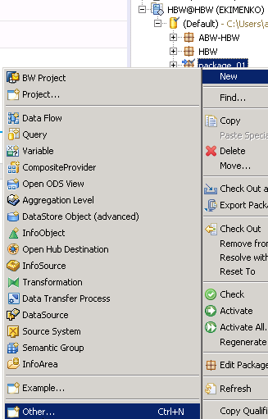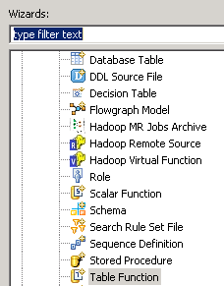

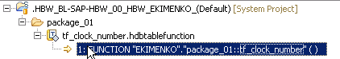

FUNCTION "EKIMENKO"."package_01::tf_clock_number" ( )
RETURNS
TABLE ("/BIC/BPERSNUM" varchar(30),
DATETO varchar(8),
DATEFROM varchar(8),
TXTMD varchar(40),
TXTLG varchar(100)
)
LANGUAGE SQLSCRIPT
SQL SECURITY INVOKER AS
BEGIN
return
select "/BIC/BPERSNUM", DATETO, DATEFROM, TXTMD, TXTLG
from "SAPABAP1"."/BIC/TBPERSNUM";

END;

Calculation View

На примере
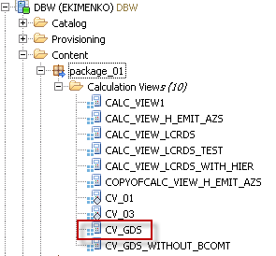

Иерархия

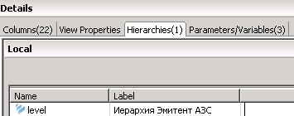

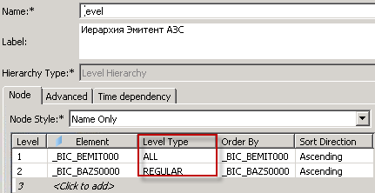

Вычисляемое поле

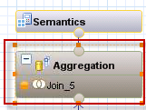

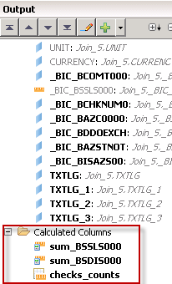

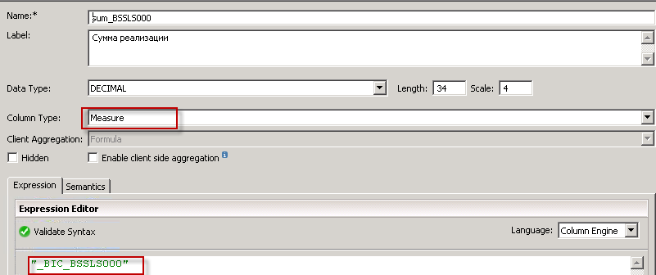

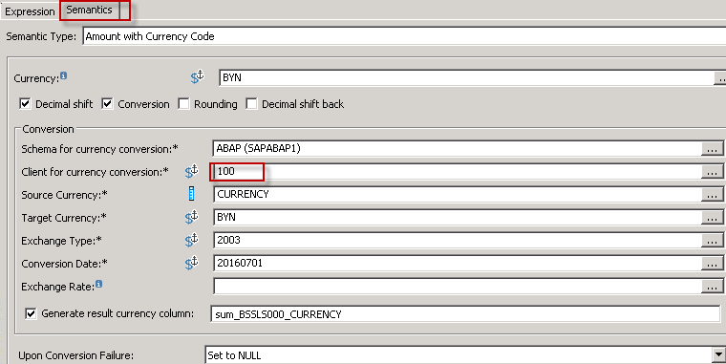

RS2HANA_VIEW

Before you start to generate "external BW HANA view" it is necessary to think about some general settings e.g. which package should be used,
With 7.5 and support package 4 or higher you have the following options in transaction RS2HANA_VIEW.

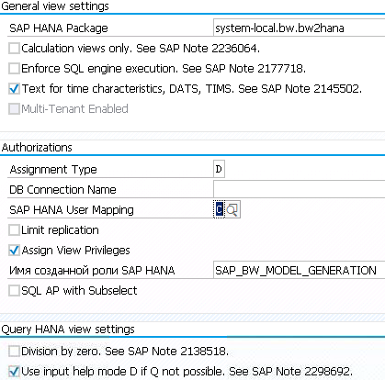

All other settings are described in the following notes -

2236064 | External SAP HANA view: always create calculation view
2177718 | External SAP HANA view, performance: enforce SQL engine execution
2145502 | External SAP HANA view: text column for time characteristics and characteristic
2138518 | External SAP HANA view for Query: Division by zero
2298692 | External SAP HANA view for Query: "filter values selection" setting, input valu

After inserting or changing an entry in table RS2HANA_VIEW_SET it is necessary to reset the buffer by /$TAB RS2HANA_VIEW_SET or /$SYNC
Details are available in SAP note 2252122: Technical Customizing of HANA View Generation (RS2HANA_VIEW_SET)

CONTENT HANA PACKAGE:
Per default the Content HANA Package is 'system-local.bw.bw2hana' and can be checked in table RS2HANA_VIEW_SET or RS2HANA_VIEW.
Changing an existing package is only possible if the package is empty.
In the HANA studio it is not allowed to use the defined package or any subpackage for any other objects then the generated BW external HANA view.

Multiple BW System on one HANA
If multiple BW systems share on HANA instance, it is mandatory to set a different package in each system.

possible automatically generated sub-packages see RS2HANA_ADMIN

2236064 - External SAP HANA view: always create calculation view
https://launchpad.support.sap.com/#/notes/2236064

Solution
To ensure that all external SAP HANA views are of type calculation view, create an entry in table RS2HANA_VIEW_SET with OBJECT = RS2HANA_CALCVIEW_ONLY and VALUE = X. Execute command /$TAB in the command field of the ABAP backend to reset the table buffers in the system to ensure the new setting is applied.
Alternatively use transaction SE24 to execute method SET_CALCVIEW_ONLY( X ) of class CL_RS2HANA_VIEW_SETTINGS if available.

When a BW object is activated, or transaction RS2HANA_ADMIN is used to repair an external SAP HANA view, two steps are executed with regard to this setting:
- If there is already an external SAP HANA view for the BW object, which is not of type calculation view, it is deleted.
- An external SAP HANA view of type calculation view is deployed. The name of the resulting column view in the _SYS_BIC schema is the same as before. Thus no change is necessary regarding used SQL statements.

Attention: References to the generated external SAP HANA views from other, manually created SAP HANA views can therefore be lost and need to be adjusted manually.
In order to avoid this issue proceed as follows:
a) ensure SAP Note 2555138 is implemented
b) stop all activities in the BW system which could lead to an activation of a BW object and do not use transaction RS2HANA_ADMIN
c) Migrate all generated external SAP HANA views of type Attribute or Analytic View to Calculation view with the SAP HANA studio. In the Quick View you can find a Migrate function with a corresponding option. This Migrate function will automatically adjust the references for other impacted content objects. See note 2325817 for details about this migration process.
d) Activate the Calculation view only setting in the BW backend
e) Use transaction RS2HANA_ADMIN to repair all external SAP HANA views which have been manually migrated. This will overwrite the migrated views but keep the references.

SAP Note 2317197 shows the type of the external SAP HANA view for each supported BW object type. BW objects where the type is Calculation view are not affected by this functionality. This list can be found at question "Q: What is the type of the external SAP HANA view".

SYS_BIC: SAP DBTech JDBC: [258]: insufficient privilege: Not authorized
− We run BW on HANA and I want to create a HANA model using BW tables.
I have tried to create a Calc. view and Analytical view using a DSO Table. I can validate and activate the model without a problem but I cannot see the Data preview. The following error is occured:

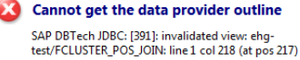

_SYS_REPO has all the privileges to access my Schema.
With the statement

SELECT * from "_SYS_BIC"."ehg-test/EHG_DSO_CALC"

I don't have sufficient privileges.
When I create a Calc. view with a script I can see the Data

select rt_asort, count(distinct rt_locatio) as filial
from "SAPBW3"."/BIC/AAAAD_CLT00"
group by rt_asort;

Has anyboby faced something like that? Which privileges are required for this operation?
Thanks in advance,

− SAP Note 1761917 resolved this issues
Executing or activating an Analytic Object fails with "user is not authorized" or "invalidated view"
Resolution
- Make sure _SYS_REPO has privilege SELECT WITH
GRANT OPTION for the schemas used. In order to grant _SYS_REPO this privilege
you can execute the following statement:

GRANT SELECT ON SCHEMA <YOUR_SCHEMA> TO _SYS_REPO WITH GRANT OPTION;

- Make sure the user activating the Object has at
least SELECT privilege over the schemas used within the scenario. SQL
statement to grant this privilege would be:

GRANT SELECT ON SCHEMA <YOUR_SCHEMA> TO <USER_THAT_WILL_ACTIVATE_ANALYTIC_OBJECT>;

- Make sure all the dependencies of the Analytic
Object to be activated is contained in the Analytic Privilege assigned to the
user that will actually activate the Main Analytic Object.

SAP DBTech JDBC: [258]: insufficient privilege ... again!
The following statement on composite provider 'COM_PROV_XYZ':

select * from "_SYS_BIC"."system-local.bw.bw2hana/COM_PROV_XYZ";

fails with the message:

Could not execute 'select * from "_SYS_BIC"."system-local.bw.bw2hana/COM_PROV_XYZ"'
SAP DBTech JDBC: [258]: insufficient privilege

The following select on calc view 'YYY' works though:

select * from "_SYS_BIC"."ProjectX/YYY"

Which agrees with the fact that the user has been granted roles with the followin auths:

SELECT * FROM "PUBLIC"."GRANTED_PRIVILEGES"

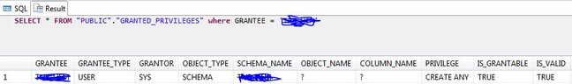

− Have you tried running a trace whilst reproducing the error?
Please see the Troubleshooting Authorizations Guide (https://wiki.scn.sap.com/wiki/display/SAPHANA/Troubleshooting+SAP+HANA+Privileges+and+Authorisations) for information on how to activate the trace.

− Yes switch to 'yes'. The issue is you seem to be missing the privilege for the object in SYS_BIC (A9CO_ER_ES07). Grantable to others should fix this

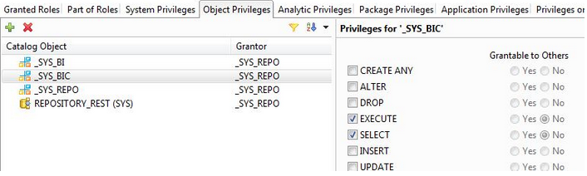

− I order to view the data, Analytic privileges on the view are required for the user apart from the _SYS_BIC and _SYS_BI privileges.
Also, the trace above mentions:
User XXX is not authorized to access _SYS_BIC.system-local.bw.bw2hana/A9CO_ER_ES07 because he is missing any structured privileges applicable to that object

Here, structured privileges refer to the analytic privilege to the user. Can you check if the user has the respective Analytic privilege.

For analytic privilege you can refer the help.sap.com at
Analytic Privileges - SAP HANA Developer Guide for SAP HANA Studio - SAP Librar

What is _SYS_BIC and _SYS_REPO, and their differences?
− What is _SYS_BIC and _SYS_REPO, and their differences?
− Both are system users and there schemas are system schemas. Whenever we create a model and activate it, the runtime column views are created and stored under column view section of _SYS_BIC schema. Whatever (независимо от того, что) we are modelling in a view cannot be accessible for front end tool like BO directly. They can access only the objects in Catalog section. So only way to get the data by front end tools is query column views in _SYS_BIC.
Whenever we create a model, _SYS_REPO user creates necessary runtime objects from them which get saved into _SYS_BIC schema. After activation _SYS_REPO gives the user read access to the activated models. This is why it is necesary to grant _SYS_REPO with SELECT WITH GRANT previlage to the users schema.
Refer below link to see a very detailed explanation from Lars on _SYS_REPO.
http://scn.sap.com/thread/3153367
And if you are wondering why we need all these specific schemas, I think the answer would be, with the help of these system schemas, authorization and data management happen in SAP HANA.

Задания developer2

Отменено
- BI_DELETE_OLD_MSG_PARM_DTPTEMP, ежедн. 12:00
Программа RSBATCH_DEL_MSG_PARM_DTPTEMP - Удаление старых сообщений, параметров и DTP-данных шаблонов.
- BI_PROCESS_TRIGGER, ежедн. 5:00

Тип рабочего процесса BTC – партия

Цепочки
- 1:00 ежедн.
- 1:00 ежедн.
- 1:00 ежедн.
- 1:00 ежедн.
- 1:00 ежедн.

Операции чтения выполняются для обеих частей, тогда как операции записи выполняются только в дельта-часть. Для оптимизации производительности и сжатия данных, необходимо перенести данные из дельта-части в основную часть. Этот процесс называется дельта-слиянием.

A column store table is comprised of two index types, for each column - a main index and a delta index.
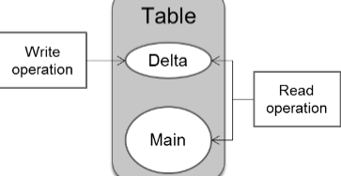

In order to optimize query execution performance of the system and to ensure optimum compression, the system needs to transfer the data from the delta part into the main part. This process is called delta merge.

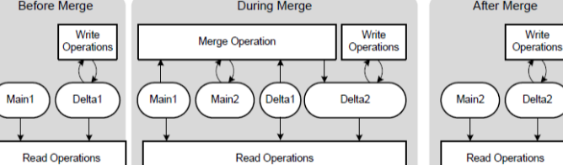

Uncommitted changes in Delta1 are copied to Delta2. The content of Main1 and the committed entries in Delta1 are merged into the new main storage Main2.

With this double buffer concept, the table only needs to be locked for a short duration starting just before open transactions are moved to delta2 and ending just after the storages are “switched”.

The minimum memory requirement for delta merge includes the current main size + future main size + current delta + some additional memory.

Every partition of a table is treated internally as a standalone table with its own data and delta store. For partitioned tables therefore, the amount of needed main memory during the merge is reduced, depending on the size of the partition.

Caution!
Before a table is (re-)partitioned, a delta merge is executed. Therefore you have to partition tables in time to not run out of memory during a merge for huge tables.

One can put the different merge types in two categories for instance, the ones that are
autom
atically executed by the system via a process called mergedog and the ones that can be
triggered manually, either through an application (e.g. BW) or by a user sending an SQL statement
to HANA.

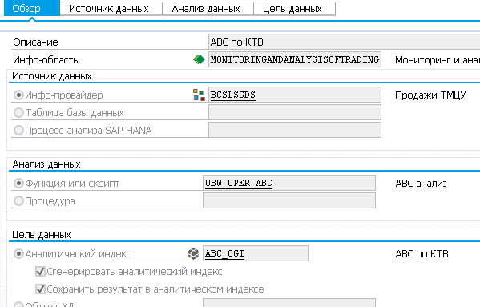

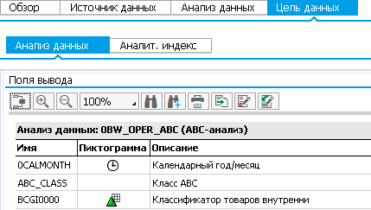

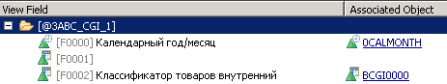

Инфо-провайдер BCSLSGDS
Функция или скрипт OBW_OPEC_ABC
- >Item
- >Item
- >Value

Create a input parameter to call stored procedure
− I am creating input parameter in hana graphical represent calculation views.
While creating input parameter I selected derived from stored procedure.
After that I select stored procedure it was giving below error

Procedures with output parameters of type Table not supported

The below code was my procedure

BEGIN
COLUMN_SEC=
SELECT MAX(COLUMN_SEC) AS COLUMN_SEC
FROM (
SELECT
CASE WHEN ROLE_NAME LIKE '%ALL%' THEN 1 ELSE 0
END AS COLUMN_SEC
FROM SYS.GRANTED_ROLES
WHERE GRANTEE = SESSION_USER
);
END;

and I created out parameter as well as

− For that parameter type you can only use a stored procedure (or scalar UDF) returning a scalar value. Your procedure will have a table typed output parameter which is not supported at the moment.

− In this scenario may I know how do I create a stored procedure returning a scalar value.

− Here is a dummy example for a procedure returing a string 'Test' and the usage the procedure for a parameter in a calc. view. Personally I would use a scalar UDF for that.
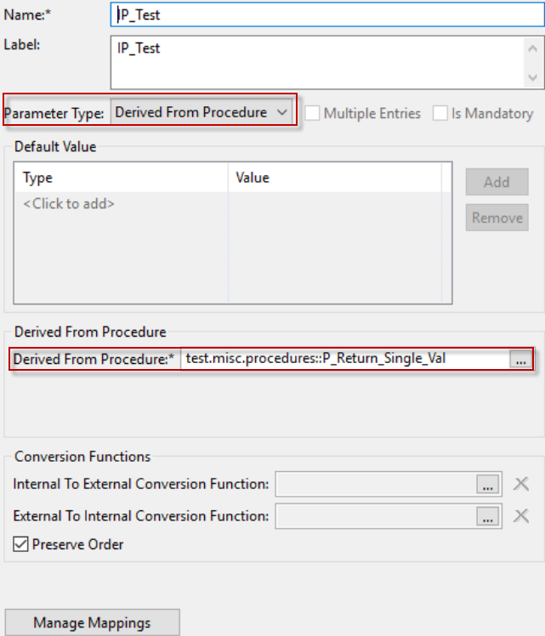

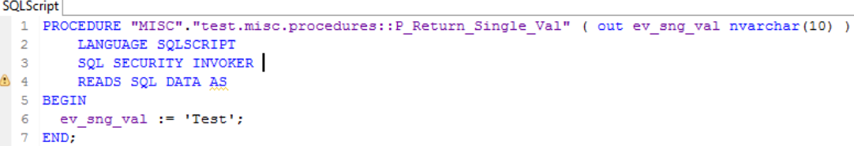

− I created procedure as below

CREATE PROCEDURE "SOAR"."KS_COLUMN_TEST"(OUT COLUMN_SEC NVARCHAR(10))
LANGUAGE SQLSCRIPT
SQL SECURITY INVOKER
READS SQL DATA AS
BEGIN
COLUMN_SEC := 'TEST';
END;

after that I am creating parameter in calc view, by that time it was thrown an error

Procedure must have scalar parameter of type String as the output parameter

− Make sure there is no authorization issue in your system, you can execute below SQL and check again,

GRANT EXECUTE ON SCHEMA <YOURSCHEMA> TO _SYS_REPO WITH GRANT OPTION;

SAP HANA Calculation View Tutorial

SAP HANA Analytic view measure can be selected from only one fact table. When there is need of More Fact table in information view then calculation view come in the picture.
The data foundation of the calculation view can include tables, column views, analytic views and calculation views.
SAP HANA Calculation View are of two types –
- SAP HANA Graphical Calculation View.
- SAP HANA Script-based calculations Views (Created by SQL Scripts by SAP HANA Studio).
Projection is used to select columns, filter the data and create additional columns before we use it in next nodes like a union, aggregation and rank.
Aggregation is used to perform aggregation on specific columns based on the selected attributes.
Rank is the exact replacement for RANK function in SQL. We can define the partition and order by clause based on the requirement.
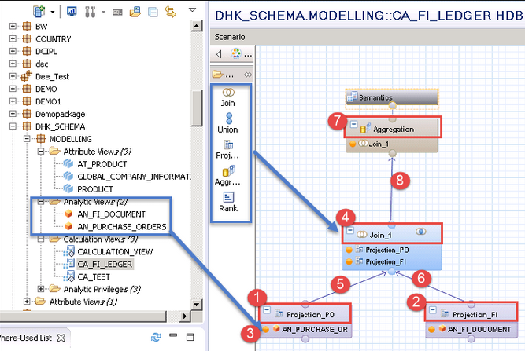

CE Functions also known as Calculation Engine Plan Operator (CE Operators) are alternative to SQL Statements.
CE function is two types –
- Data Source Access Function - binds a column table or a column view to a table variable -
- CE_COLUMN_TABLE
- CE_JOIN_VIEW
- CE_OLAP_VIEW
- CE_CALC_VIEW
- Relational Operator Function - user can bypass the SQL processor during the evaluation and communicate with calculation engine directly -
- CE_JOIN - is used to perform inner join between two sources and read the required columns/data.
- CE_RIGHT_OUTER_JOIN - is used to perform right outer join between the two sources and display the queried columns to the output.
- CE_LEFT_OUTER_JOIN.
- CE_PROJECTION - display the specific columns from the source and apply filters to restrict the data. It provides column name aliase features also.
- CE_CALC - is used to calculate additional columns based on the business requirement.

Below is a list of SQL with CE function with some Example –

Query Name | SQL Query | CE-Build in Function
Select Query On Column Table | SELECT C, D From COLUMN_TABLE. | CE_COLUMN_TABLE(COLUMN_TABLE, [C, D])
Select Query On Attribute View | SELECT C, D From ATTRIBUTE_VIEW | CE_JOIN_VIEW(ATTRIBUTE_VIEW, [C, D])
Select Query on Analytic View | SELECT C, D, SUM(E) From ANALYTIC_VIEW Group By C, D | CE_OLAP_VIEW(ANALYTIC_VIEW, [C, D])
Select Query on Calculation View | SELECT C, D, SUM(E) From CALCULATION_VIEW Group By C,D | CE_CALC_VIEW(CALCULATION_VIEW, [C, D])
Where Having | SELECT C, D, SUM(E) From ANALYTIC_VIEW Where C = 'value' | Var1= CE_COLUMN_TABLE(COLUMN_TABLE); CE_PROJECTION(:var1, [C, D],"C" ="value"/

The main difference to arbitrary joins is that the star schema assumes a central fact table that contains all key figures that should be aggregated, while all selection criteria are defined on dimension tables that are then joined to the fact table.
If you have a star schema, you want to use the star join for better performance and a more expressive model.

